Project Design Phase-II
Solution Requirements (Functional & Non-functional)

Date | 9 July 2026
Team ID
Project Name | ShopEZ
Maximum Marks | 4 Marks

Functional Requirements:
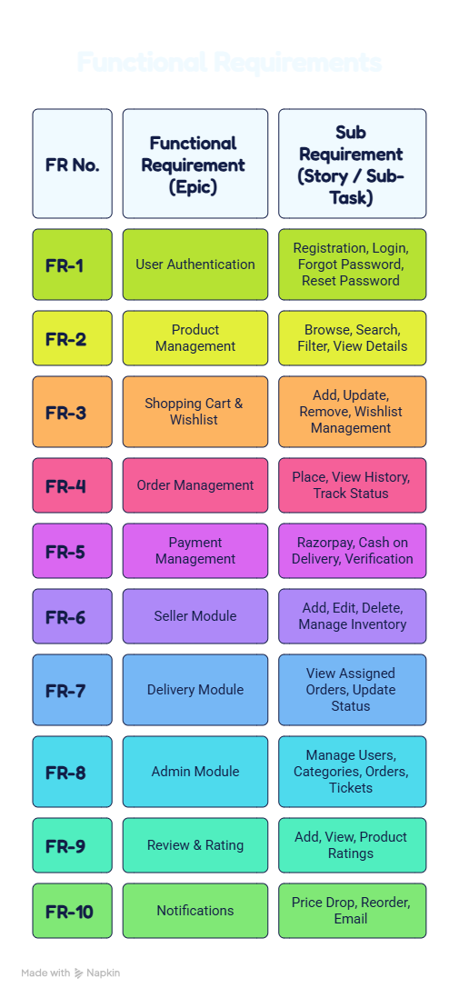

Non-functional Requirements:
